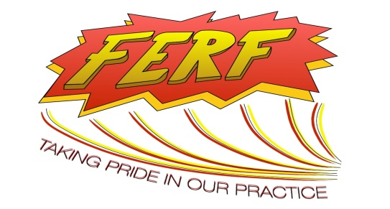
Your logo

Date: 19 September 2016

Congratulations on receiving a FERF!

Dear

You received a FERF (on for)

The FERF initiative within our Emergency Department formally acknowledges examples of good practice. The idea is to recognise and celebrate when a team or a person has performed really well and encourage learning from it.

Favourable Event Reporting Forms or ‘FERFs’ which are filled out by any member of staff when they see something which has made a positive difference to patient care either directly or indirectly.

We display some of these on the FERF notice board in our main corridor where forms are visible to all staff, visiting teams, patients and relatives. We also share specific learning points at M&Ms, education meetings or wherever most appropriate. Individuals involved each receive a letter of recognition for their professional portfolios.

We would like to congratulate you and thank you for contributing so positively to emergency care in our department.

Signature | Signature
Name  Emergency Department Consultant | Name  Emergency Department Matron
On behalf of the Emergency Department FERF team

